Cidoc
Comité international pour la documentation, conseil international des musées
International documentation committee, international council of museums

DRAFT INTERNATIONAL CORE DATA STANDARD FOR ARCHAEOLOGICAL SITES AND MONUMENTS

Table of Contents
Production: CIDOC Archaeological Sites Working Group
(1995)
Text: Members of Group
ISBN 92-9012-125-4
This publication is available through credit card orders for 10.00 USD in various languages from ICOM, Maison de Unesco, 1, Rue Miollis, 75732, Paris, cedex 15 France
tel.: +33 1 47340500, fax: + 33 1 43067862
Table of Contents
List of Figures
PREFACE
1. INTRODUCTION
1.1. Aims of the Core Data Standard
1.2. Using the Core Data Standard
1.3. The Future of the Core Data Standard
1.4. Contacts for comments
2. The Theoretical Framework
3. THE CORE DATA STANDARD
3.1. Names and References
3.1.1. Reference number
3.1.2. Name of monument or site
3.1.3. Date of compilation and date of last update
3.1.4. Originator of reference
3.1.5. Cross reference to related records of monuments or sites
3.1.6. Cross reference to archaeological collections and artifacts
3.1.7. Cross reference to documentation
3.1.8. Cross reference to archaeological events
3.2. Location
3.2.1. Administrative location
3.2.2. Site location
3.2.3. Address
3.2.4. Cadastral reference/Land unit
3.2.5. Cartographic reference
3.3. Type
3.3.1. Monument or site type
3.3.2. Monument or site category
3.4. Dating
3.4.1. Cultural period
3.4.2. Century
3.4.3. Date range
3.4.4. Scientific and absolute dates
3.5. Physical Condition
3.5.1. Condition
3.5.2. Date condition assessed
3.6. Designation/Protection Status
3.6.1. Type of designation or protection
3.6.2. Date of designation or protection
3.6.3. Reference number
3.6.4. Originator of reference
3.7. Archaeological Summary
4. IMPLEMENTING THE CORE DATA STANDARD
4.1. The CIDOC Data Model 21
4.2. Existing Data Models
4.3. Use of Controlled Vocabulary and Thesauri
4.4. Mapping Systems
5. Glossary
5.1. Theoretical Framework Elements
5.2. General Terms
6. Bibliography
APPENDIX: EXISTING DATA MODELS FROM NATIONAL ARCHAEOLOGICAL RECORDS
Denmark: The National Archaeological Record (Det kulturhistoriske Centralregister - DKC)
England: The MONARCH Heritage Database Management System
France: the DRACAR System
Netherlands: The ARCHIS system

List of Figures
Figure 1:Theoretical Framework
Figure 2: CIDOC Data Model
Figure 3: DKC, Denmark, Data Model
Figure 4: MONARCH, England, Data Model
Figure 5: DRACAR, France, Data Model
Figure 6: ARCHIS, Netherlands, Data Model

Blank Page
Preface
This core data standard for archaeological sites and monuments has been prepared by two organisations working in close cooperation. The work of CIDOC, the documentation committee of the International Council of Museums (ICOM), has been undertaken in close collaboration with archaeological and architectural working parties contributing to the documentation programme of the Council of Europe's Cultural Heritage Committee. The preparation of an international core data standard for archaeological sites was one of the principal aims of the CIDOC Archaeological Sites Working Group established in September 1992 at the CIDOC Quebec meeting.
Between 1987-1992 a core data standard was prepared for records of architectural sites and monuments, within the Council of Europe programme created to support the European Convention for the protection of the Architectural Heritage. This architectural data standard was agreed at an international colloque at Nantes in October 1992.
The core data standard for archaeological sites produced by the CIDOC group has retained a close relationship to that prepared for architectural monuments by the Council of Europe in order that countries able or wishing to include all information relating to the historic environment on one database could do so.
The individuals and countries represented in the work of the CIDOC Archaeological Sites Working Group are:
Roger Leech (United Kingdom)
Judy Marsh (Canada)
Veletta Canouts (United States of America)
Nigel Clubb (United Kingdom)
Dominique Guillot (France)
Henrik Hansen (Denmark)
Zana Kamberi (Albania)
Irina Oberlander-Tarnoveanu (Romania)
Andrzej Prinke (Poland)
Gillian Quine (United Kingdom)
Trevor Reynolds (United Kingdom)
Stephen Stead (United Kingdom)
Elena Tashak (Russia)

Introduction
Blank Page

Aims of the Core Data Standard
The documentation of archaeological sites and monuments plays an essential role in promoting the understanding, conservation and preservation of the archaeological heritage. Within Europe, a wide range of recording methods are employed in the compilation of inventories, often within a national framework. The compilation of these various inventories may have occurred for a variety of different reasons. However, some of these reasons enjoy a more widespread currency, in particular those relating to the protection of the archaeological heritage, and to providing some form of public access to the information held. The aims of this document are therefore threefold:
- to facilitate communication between national and international bodies responsible for the recording and protection of the archaeological heritage.
- to assist countries at an early stage in developing record systems for the recording and protection of the archaeological heritage.
- to facilitate research utilising archaeological core data where this has an international dimension.
In the form presented here, the core data standard for archaeological sites has retained a close relationship to that prepared for architectural sites by the Council of Europe. This should be advantageous to countries able or wishing to include in one database all information relating to the man-made environment. This standard can moreover also be linked with a working standard prepared by CIDOC for archaeological objects (CIDOC 1992) and with the CIDOC minimum data standard for museum objects (CIDOC 1995) which includes archaeological objects.

Using the Core Data Standard
The core data standard, Chapter 3, should be used in conjunction with the data model selected for the national or regional database. The data model will, in most cases, require modification to reflect the requirements of the organisation. Chapter 4 is intended to provide further guidance and information on implementing the core data standard.
The various sections into which the data standard is divided represent the minimum categories of information required to make a reasonable assessment of a monument or site, whether for planning, management, academic or other purposes. In addition, reference can be provided to further information held in databases, document centres and elsewhere which may be necessary for the detailed understanding and care of individual monuments or sites or categories of monument or site.
The mandatory sections within the data standard provide for a minimum amount of information required for indexing in structured fields and describing in free text fields an archaeological monument or site. The optional sections, sub-sections and fields allow for the recording of a monument or site in greater detail. For example a site may be cross-referenced to a larger complex of which it forms a part, or to records of excavations undertaken on the site. Cross-referencing can also be made to more detailed documentary information either held by or known to the organisation responsible for the particular monument or site record. Clearly the level of recording undertaken by individual organisations will vary according to its own requirements and resources.
Not all the sections are mandatory. Each section contains a varying number of sub-sections, some of which are mandatory, ie the information must be recorded, while others are optional ie recording of information depends upon the priorities of the recording organisation. Alternatively, of course, the information may not exist. For example, there may never have been an excavation undertaken at a particular site, in which case sub-section 1.8 cannot be completed.
While many of the sub-sections are optional, once it has been decided to record the type of information they refer to, then some or all of the fields within the sub-section become mandatory. For example, if it is decided to make cross-reference to records of archaeological excavations/events (sub-section 3.1.8), then the reference number of that excavation record and the name of the organisation responsible for curating that record must be entered.
The individual sections are as follows:
- Section 1 identifies the monument or site, and allows cross-referencing to records of events, eg excavation and/or survey undertaken at that site, and to records of artefactual and archival material associated with the site;
- Section 2 locates the monument or site in terms of address, political, cartographic and other spatial criteria;
- Section 3 describes the type of monument or site being recorded;

- Section 4 allows for a date to be assigned to a monument or site, or for dates to be assigned to particular phases of use;
- Section 5 records the physical condition of the monument or site;
- Section 6 permits a note to be made of any form of protection, legislative or otherwise, which applies to the monument or site;
- Section 7 provides for a brief summary of what is known, archaeologically, about the monument or site.
Although many of the entry fields within the sections and sub-sections require only a single piece of information (designated 'unique' within the data standard), it is recognised that in certain instances two or more terms may be relevant to a particular monument or site within a single field, sub-section or section. For example, an archaeological site may straddle the border of two adjacent administrative areas, or more than one excavation may have taken place at a particular site. In such instances, the data standard recommends the repetition of the whole sub-section or section rather than 'multiple entry' within one field. Thus in the example of more than one excavation at a particular site, each would be treated as a separate event and the whole of the cross-references in 3.1.8 would be repeated for each excavation record.

The Future of the Core Data Standard
The core data standard presented here is very much a draft document, to be further considered in a world context, and in the light of experience in using it for its intended purposes. The CIDOC Archaeological Sites Group intends to test the core data standard through a carefully selected project drawing on data world wide. It is intended to prepare a second version of the standard, based on comments received together with world-wide experiences and consultations.
Finally, it must be emphasized that this data standard is intended as a guide. Different organisations in different countries record archaeological information for different reasons and to varying degrees of detail. For this reason, a number of the sections, sub-sections and fields are optional rather than mandatory, in order to allow different organisations to record to a level appropriate to their aims and resources.

Contacts for Comments
Dr. Roger Leech
Royal Commission on the Historical Monuments of England
National Monuments Record Centre
Kemble Drive
Swindon SN2 2GZ
United Kingdom
Dr. Veletta Canouts
Archaeological Assistance Division
National Parks Service
U.S. Department of the Interior
P.O. Box 37127
Washington DC 20013-7127
U.S.A.
Dominique Guillot
Ministère de la Culture et de la Francophonie
Direction du Patrimoine
Sous-direction de l’Archéologie
4, rue d’Aboukir
75002 Paris
France

The Theoretical Framework
The core data standard has been devised within a theoretical framework. This can be employed in both manual and computer-based systems. For possible approaches to implementation, see Chapter 4.
The theoretical framework is shown in Figure 1 and consists of four elements:
- Archaeological items
- Archaeological groups
- Physical spaces
- Physical groups
Archaeological items are the fundamental pieces of archaeology which may be individual artifacts and ecofacts, components of sites and monuments such as walls and post-holes or even complete monuments depending on levels appropriate to the objectives of the data. The framework enables archaeological items with known archaeological relationships or associations to be brought together as archaeological groups. Examples might include the set of flint flakes, tools and the core that form a flint nodule after refitting or the sherds that form a ceramic vessel. Dissimilar items may also be grouped such as the set of constructional (mound, stone chamber and ditch), artefactual (jewellery, stone tools and ceramics) and ecofactual (skeletal remains, pollen and buried soil) archaeological items.
Archaeological items occupy physical spaces in the real world. For example, the physical spaces used in an excavation record would be the contexts excavated and in a site inventory they might be areas of land with statutory protection.
A physical group is a collection of two or more physical spaces which form larger physical spaces within which archaeological items and groups may occur. Examples might include the grouped set of areas of land that constitute a statutorily protected monument or the group of excavation levels or contexts which make up a ditch and its fill. They need not be contiguous, as for instance where parts of a linear feature are divided by modern intrusions which totally destroy the archaeology.
The relationships between the different elements are governed by certain rules as follows:
- An archaeological item will exist in one or more physical space
- An archaeological item may exist on its own or as part of an archaeological group or groups
- Physical spaces should not overlap with other physical spaces although on rare occasions they may appear to where data is imprecise or inaccurate.
Further definitions of the elements appear in the first section of the glossary (5.1).
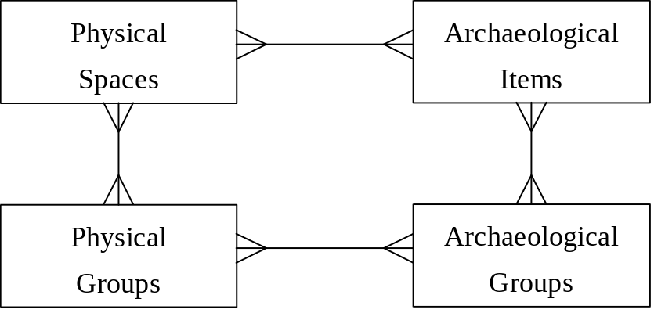

Figure 1:Theoretical Framework

The Core Data Standard
Blank Page

The following presents the definitions of the sections, sub-sections and fields proposed for the Core Data Standard. Some of these are mandatory, others are optional and the need to complete them will vary according to the nature of the record held and to the individual organisational requirements:

Names and References
This is a mandatory section which identifies the monument or site.

Reference number
The number or combination of characters which uniquely identifies each monument or site recorded by the organisation, eg 615649.
(Alphanumeric, Unique, Mandatory)

Name of monument or site
A free-text field which records the name or names by which a monument or site was or is known, eg Stonehenge, Little Big Horn, Field system at West Cliff.
(Alphanumeric, Unique, Optional)

Date of compilation and date of last update
This sub-section records the date of compilation and last update.

Date of compilation
The date the core data record was created. The ISO standard for date is recommended, eg 1986-06-22.
(Alphanumeric, Unique, Mandatory)

Date of last update
This date will be modified whenever the record is updated. The ISO standard for date is recommended, eg 1993-07-12.
(Alphanumeric, Unique, Mandatory)

Originator of reference
Name of the individual or organisation responsible for curating the monument or site record. This information is useful in establishing the provenance of the record when data is exchanged between recording organisations, eg National Heritage Conservation Commission.
(Alphanumeric, Unique, Mandatory)

Cross reference to related records of monuments or sites
This sub-section enables cross referencing to related records. For example, relating a record to its wider complex record, eg a house within a settlement. It is optional and can be repeated.

Reference number
The number or combination of characters which uniquely identifies each related record, eg SM97342.
(Alphanumeric, Unique, Mandatory)

Qualifier of Relationship
The qualifier indicates the type of relationship between one record and another, such as a hierarchical "parent - child" relationship linking an archaeological complex and an individual site. The entry will be one of the following: "Part of", "Contains" or "Related to". In the record for the house the relationship to the settlement would be "Part of ". In the record for the settlement the relationship to the house would be "Contains". The house could also have a relationship of "Related to" another house.
(Alphanumeric, Unique, Mandatory)

Originator of reference
Name of the individual or organisation responsible for curating the related record, eg National Cultural History Museum.
(Alphanumeric, Unique, Mandatory)

Cross reference to archaeological collections and artefacts
This sub-section enables cross referencing to related records of Archaeological Collections. It is optional and can be repeated.

Reference number
The number or combination of characters which uniquely identifies each related collection or artefact, eg 57486.
(Alphanumeric, Unique, Mandatory)

Originator of reference
Name of the individual or organisation responsible for curating the related record, eg Nationalmuseet (DKC).
(Alphanumeric, Unique, Mandatory)

Cross reference to documentation
This sub-section enables cross referencing to the published and unpublished documentation associated with the site or monument. It is optional and can be repeated.

Reference number
The number or combination of characters which uniquely identifies each related piece of documentation, eg DD27483.
(Alphanumeric, Unique, Mandatory)

Type of documentation/archive
The type of documentation or archive associated with the site. Controlled vocabulary is desirable, eg photographic, graphic, unpublished text, bibliographic, electronic and cartographic.
(Alphanumeric, Unique, Mandatory)

Originator of reference
Name of individual or organisation responsible for curating the related record, eg Royal Commission on the Historical Monuments of England.
(Alphanumeric, Unique, Mandatory)

Cross reference to archaeological events
This sub-section makes it possible to relate, for example, records of archaeological excavations or surveys to those of the monument or site. Where multiple events have occurred at a monument or site, eg a survey followed by excavation, separate entries in this sub-section should be completed. It is an optional sub-section which can be repeated.

Reference number
The number or combination of characters which uniquely identifies each related event, eg CX974\38.
(Alphanumeric, Unique, Mandatory)

Type of event
The nature of the event, eg excavation, survey. Where multiple events have occurred each should have a separate entry.
(Alphanumeric, Unique, Mandatory)

Start date of recording event
The date on which the recording event commenced. The ISO standard for date is recommended, eg 1896-06-24.
(Alphanumeric, Unique, Optional)

End date of recording event
The date on which the recording event terminated. The ISO standard for date is recommended, eg 1896-07-30.
(Alphanumeric, Unique, Optional)

Originator of reference
Name of individual or organisation responsible for curating the related record, eg Department of Environmental Affairs and Tourism.
(Alphanumeric, Unique, Mandatory)

Location
This is a mandatory section which locates the monument or site.
Any combination of sub-sections defined below may be employed to identify the location of the monument or site. More than one type of sub-section may be used to more closely define the location or to make otherwise ambiguous locations more precise. It should be noted that at least one sub-section must be used but that no individual sub-section is mandatory.

Administrative location
This is an optional sub-section for details of administrative location which can be repeated.

Country or nation
The name of the country or nation within which the monument or site is located, eg France.
(Alphanumeric, Unique, Optional (Mandatory for exchanging data with other countries))

Geo-political unit
Used for recording geographical or political subdivisions of countries or nations; for instance States in the United States, Régions in France, Länder in Germany, Countries in Great Britain, Provinces in Canada, eg British Columbia.
(Alphanumeric, Unique, Mandatory)

Administrative sub-division
According to the administrative structure of each nation/country, a number of repeat entries in this field may be required. For example in Great Britain the Country is further subdivided into County, District and Parish, eg Wiltshire, Salisbury, Amesbury and so would require three entries.
(Alphanumeric, Unique, Mandatory)
It should be noted that it is essential to differentiate between different levels of administrative sub-divisions, eg local or regional.

Site location
This is an optional sub-section for free-text record of site location.

Description of location
A free text field enabling a short description of the location of a monument or site to be recorded, to assist identification in the field, and to provide a more precise location for sites in sparsely populated areas, eg four kilometres North East of Lake Michigan.
(Alphanumeric, Unique, Mandatory)

Address
This enables the recording of the location of monuments or sites which have a postal address, especially those within built-up areas. It is an optional sub-section and can be repeated for example if the monument or site is located on two streets or has two postal names. All of the fields are optional but at least one must be completed.

Name for address purposes
Use this field for the name for address purposes (or postal name), eg Cruive Cottage, Bacon’s Castle.
(Alphanumeric, Unique, Optional)

Number in the street/road
Use this field for the number in the street/road, eg 27A.
(Alphanumeric, Unique, Optional)

Name of street/road
Use this field for the name of the street/road, eg Calea Victoriei.
(Alphanumeric, Unique, Optional)

Locality
Used for commonly known non-administrative units such as hamlets and townships, eg Pincevent.
(Alphanumeric, Unique, Optional)

Town/City
Use this field for the name of the town or city, eg Tokyo.
(Alphanumeric, Unique, Optional)

Postal or zip code, or other similar national address code
Use this field to record an address code, eg 670000, K1A 0C8.
(Alphanumeric, Unique, Optional)

Cadastral reference/Land unit
Some countries have a system of allocating reference numbers to individual blocks of land. The reference number relevant to the particular monument or site can be entered here. It is optional and can be repeated.

Cadastral Reference
Enables cross reference to the land unit/parcel(s) current in some nations/countries, eg block reference 9417\278.
(Alphanumeric, Unique, Mandatory)

Cartographic reference
This is an optional sub-section used to record the two- or three-dimensional spatial co-ordinates required for locating the monument or site within the mapping system(s) used by individual countries/nations. The four fields 3.2.5.5-8 should be repeated for each set of co-ordinates.

Cartographic Identifier
The identifier of the cartographic entity where the monument or site has more than one such entity related to it, eg polygon 1.
(Alphanumeric, Unique, Optional)

Spatial Referencing System
The spatial referencing system employed, eg UTM, Lambert, GPS, Ordnance Survey.
(Alphanumeric, Unique, Mandatory)

Topology
Specifies whether the cartographic reference relates to a point, line or area, ie P, L, A.
(Alphanumeric, Unique, Mandatory)

Qualifier
Allows the qualification of the cartographic reference for a monument or site to indicate the significance and reliability, eg approximate, centre. Controlled vocabulary is desirable.
(Alphanumeric, Unique, Mandatory)
The following four fields should be repeated for each co-ordinate

Sequence Number
Where an archaeological site or monument is of linear or polygonal shape, it may be advisable to list a series of sets of co-ordinates describing its course rather than a single reference to eg its central point. These should be listed in sequence. The sequence number for each set of co-ordinates should be entered here. For example 1 for a point, 1,2... for a line and 1,2,3... for a polygon.
(Alphanumeric, Unique, Mandatory)

Z-coordinate
Value or identifier of cartographic reference. It locates a record in relation to a vertical datum, eg 30 metres above sea-level, 30 metres below chart datum for underwater sites.
(Alphanumeric, Unique, Optional)

X-coordinate
Value or identifier of cartographic reference. This is normally the east - west coordinate.
(Numeric, Unique, Mandatory)

Y-coordinate
Value or identifier of cartographic reference. This is normally the north - south coordinate
(Numeric, Unique, Mandatory)

Type
An entry is mandatory and must be linked to an entry in Section 4 (Dating), eg Villa/Roman. Controlled vocabulary is necessary and should include "unknown". This section can be repeated to accommodate changes in type at a monument or site through time.

Monument or site type
The term by which a monument has been indexed. This will normally be the interpretation of the monument by function, eg Villa. Controlled vocabulary is desirable.
(Alphanumeric, Unique, Mandatory)

Monument or site category
Broad functional category to which the type belongs, eg Residential. Controlled vocabulary is desirable. Note that if an hierarchical thesaurus is being used this field may not be required.
(Alphanumeric, Unique, Optional)

Dating
This is a mandatory section allowing for precise dating when it is known, or date ranges or periods when it is imprecise. This section can be repeated.
Sub-section 3.4.1 is mandatory but one or more of the optional sub-sections which follow it may be employed to more closely define the dating.

Cultural period
This is a mandatory sub-section for Cultural period.

Cultural period
The cultural period of the monument or site, eg Neolithic. A controlled vocabulary is desirable and must include "unknown".
(Alphanumeric, Unique, Mandatory)

Century
This is an optional sub-section for Century.

Century
The century of the monument or site, eg 17th century. This field is only appropriate for monuments or sites which belong to historic periods.
(Alphanumeric, Unique, Mandatory)

Date range
This is an optional sub-section for Date range.

From date
The earliest date in the range, eg 1640.
(Alphanumeric, Unique, Mandatory)

To date
The latest date in the range, eg 1660.
(Alphanumeric, Unique, Mandatory)

Scientific and absolute dates
This is an optional sub-section which enables a more precise date to be recorded from sources such as documentary evidence, inscriptions, radiocarbon dates and dendrochronological dates.

Date
The scientific or absolute date associated with the monument or site, eg 1580 - 1410 Cal BC (HAR-1234).
(Alphanumeric, Unique, Mandatory)

Method
This indicates the method by which the date was derived, eg Carbon 14, dendrochronology. A controlled vocabulary is desirable.
(Alphanumeric, Unique, Mandatory)

Physical Condition
This section is used to record the physical condition of the monument or site and the date of assessment. It is optional and can be repeated. It may be useful for the continued assessment of the management of the monument or site to maintain entries in this section over time. This will enable damage or deterioration to be logged. It may also be necessary to include additional fields to record management details, depending on the functions of the recording organisation.

Condition
This field records the integrity of the monument or site, eg intact, destroyed, restored, unknown etc. A controlled vocabulary is desirable.
(Alphanumeric, Unique, Mandatory)

Date condition assessed
The date on which the condition was assessed. This field is optional because many condition reports in the past may not have been dated. The ISO standard for date is recommended, eg 1994-10-27.
(Alphanumeric, Unique, Optional)

Designation/Protection Status
This is an optional section allowing for a statement on whether the monument or site is designated or protected and if so the type of designation or protection and the date at which it was granted. This section can be repeated.

Type of designation or protection
This denotes the designation or protection category. A controlled vocabulary is desirable, eg municipal, provincial state, scheduled monument, world heritage site.
(Alphanumeric, Unique, Mandatory)

Date of designation or protection
The date on which designation or protection was legally granted. We recommend the ISO standard for date, eg 1992-11-27.
(Alphanumeric, Unique, Optional)

Reference number
This records the designation or protection reference number, eg SSSI47.
(Alphanumeric, Unique, Optional)

Originator of reference
Name of individual or organisation responsible for the reference number, eg National Monuments Council. This field is mandatory if a reference number is used.
(Alphanumeric, Unique, Optional)

Archaeological Summary
This optional section enables a brief free text description of the monument or site.
(Alphanumeric, Unique, Optional)

Implementing The Core Data Standard
Chapter 2 has described the theoretical framework for the core data standard. It can be implemented using traditional or information technology. Organisations proposing to implement the data standard are likely to build on the data standard and its theoretical framework to meet their own recording needs. This chapter sets out a new CIDOC data model which can be adapted for the purposes of recording organisations.

The CIDOC Data Model
The new CIDOC model in Figure 2 is based on the theoretical framework and data standard taking account of the practical experience of organisations who have implemented systems on similar principles including DKC from Denmark, MONARCH from United Kingdom (England), DRACAR from France and ARCHIS from the Netherlands. The CIDOC model shows the relationships between archaeological items and groups, locational (physical) descriptions and the other attributes in the data standard.
A further important element of the data standard, and of archaeological databases, is the means by which various sections are linked. Clearly, all sections would need to be connected to section 1, which identifies the monument or site, the source of the record, and the date of compilation. However, in addition, other sections would need to be closely linked to each other. For example, there is a need for a particularly close relationship between section 3 (Type) and section 4 (Dating) in order to allow explicit links to be made between monument or site type and period for multi-period monuments or sites whose character changed through time, eg Enclosed Settlement/Bronze Age; Open Settlement/Iron Age; Villa/Roman.
Where a relational database is to be used the rectangular boxes in Figure 2 would represent the tables to be used.

Existing Data Models
The appendix sets out four data models developed for specific computer-based national archaeological records. Although these systems were developed before the formalisation of the data standard set out in this document, these examples will be useful for comparative purposes for organisations considering implementing new systems for archaeological records.

Use of Controlled Vocabulary and Thesauri
It is strongly recommended that consistent use is made of terms and recording of data through employment of thesauri (eg EH and RCHME, 1995), glossaries and recognised international standards, eg for citing of scientific dates.

Mapping Systems
It is recognised that most National Archaeological Records will wish to implement a mapping system which can handle the information about the geographical location of the sites. The mapping systems should be able to function together with the archaeological database. Many organisations will wish to consider the use of geographical/spatial information systems to manage the map-based record.
Figure 2: CIDOC Data Model
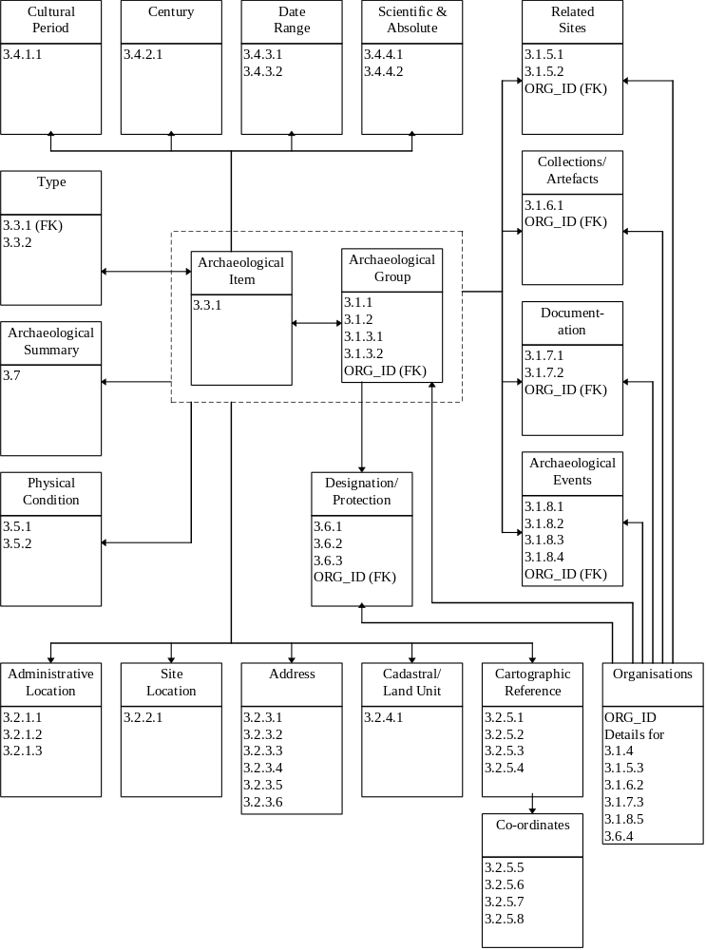

Glossary

Theoretical Framework Elements
This contains the definitions of the four elements of the Theoretical Framework (Chapter 2).
ARCHAEOLOGICAL GROUP
An archaeological group is a collection of archaeological items which form higher level constructs. These groupings of items have greater interpretative or descriptive power than the individual items. Examples would include the set of flint flakes, tools and the core that form a flint nodule after refitting or the sherds that form a ceramic vessel. Dissimilar objects may also be grouped such as the set of constructional (mound, stone chamber and ditch), artefactual (jewellery, stone tools and ceramics) and ecofactual (skeletal remains, pollen and buried soil) archaeological items.
ARCHAEOLOGICAL ITEM
An archaeological item is a fundamental piece of archaeology with which the database is concerned. Items could be artefacts like pot sherds or stone tools; ecofacts like seeds or bones; constructional elements like walls or post-holes; or monuments like temples or dwellings. The scale of the archaeological item and the attributes recorded for it will be determined by the purpose of the database.
PHYSICAL GROUP
A physical group is a collection of physical spaces which form larger spaces within which archaeological items and groups may occur. Examples would include the areas of land that constitute a statutorily protected monument or the group of excavation levels or contexts which make up a ditch and its fill. They need not be contiguous, as for instance where parts of a linear feature are divided by modern intrusions which totally destroy the archaeology.
PHYSICAL SPACE
A physical space is a division of the real world within which archaeological items are found. They can be of any size or shape and can be defined in any manner appropriate to the archaeology and task. For example, the physical spaces used in an excavation record would be the contexts excavated and in a site inventory they might be land parcels or areas of land with statutory protection. Physical spaces may not overlap. Implementational considerations, especially when concerned with data that are imprecise or inaccurate, may seem to require that this rule is relaxed. It is recommended, however, that this is done only in extreme cases.

General Terms
This contains the definitions of general terms used throughout the standard.
CADASTRAL
A system for allocating reference numbers to blocks of land.
DATA STRUCTURE
A formal arrangement of elements of data in fields which specify the expressions and format for recording data.
DESIGNATED SITE
A site which has been identified as having a particular status by an organisation; it does not imply any legal protection.
FREE TEXT
A text field, without a controlled vocabulary, which can be any length that is supported by the information system in use.
ISO
International Standards Organisation; an international organisation charged with developing standards for the international exchange of information.
LOCALITY
Any named inhabitated area; used in the core data standard for postal address where it is not the name of a town or city.
MANDATORY
Information that must be supplied ("unknown" may be an acceptable entry). In the core data standard, some sections are mandatory. Within sections that are optional, some sub-sections are mandatory if that section is used.
MONUMENT
A site with standing structural elements; site is the more inclusive term.
ORIGINATOR OF REFERENCE
Used throughout the core data standard to identify individuals or organisations which are the source of references.
PARENT-CHILD RELATIONSHIP
A hierarchical relationship between two items of data. The "parent" is one level above the "child". For a parent-child relationship, both the "parent" and the "child" must exist.
PROVENANCE
The place of origin of an object or record, or the documentation of the history of origin and transfer of objects or records. In North America the alternative spelling “provenience” is used to distinguish the former meaning.
QUALIFIER
A term which modifies the principle term, providing additional information.
SITE
Any place or set of remains so designated by an individual or organisation; usually meets formal criteria for such designation.
SITE CATEGORY
A general classification system based on the site function. It includes one or more site types with a common function.
SITE TYPE
A classification system that describes the function of the site. It is a more specific term than site category.
TOPOLOGY
The properties of a geometrical figure.
UNIQUE
Used in the core data standards to refer to a piece of discrete information that is expressed in characters (ie, words or letters), numbers, or a combination. Different pieces of discrete information are contained in separate, repeating fields.

Bibliography
Andresen, J and Madsen, T, 1992. Data Structures for Excavation Recording. A Case of Complex Information Management. In Larsen
International Council of Museums, International Committee for Documentation (CIDOC), 1992. Normes Documentaires (Archéologie)/ Data Standards (Archaeology), unpublished
International Council of Museums, International Committee for Documentation (CIDOC), 1995. International Guidelines for Museum Object Information: The CIDOC Information Categories
Council of Europe, 1993. Architectural heritage: inventory and documentation methods in Europe. Cultural Heritage 28, Council of Europe Press, Strasbourg
Royal Commission on the Historical Monuments of England and English Heritage, 1995. Thesaurus of Monument Types: A Standard for Use in Archaeological and Architectural Records. RCHME, Swindon
Grant, S, forthcoming. MONARCH The heritage information system for England, In Computer Applications and Quantitative Methods in Archaeology 1995. BAR International Series
International Organisation for Standardization, 1988. Specification for Representation of Dates and Times in Information Interchange, ISO 8601:1988/ BS EN 28601:1992, Geneva
Lang, N and Stead, S D, 1992. Sites and Monuments Records in England - theory and practice. In Lock, G and Moffett, J (eds), Computer Applications and Quantitative Methods in Archaeology 1991. BAR International Series S577, 69-76
Larsen, C U (ed), 1992. Sites and Monuments. National Archaeological Records. The National Museum of Denmark, DKC, Copenhagen
Marques, T (ed), 1992. Carta Arqueológica de Portugal. Secretaria de Estado da Cultura & Instituto Português do Património Arquitectónico e Arqueológico
Museums Services Division, 1993. Humanities Data Dictionary of the Canadian Heritage Information Network, revised edition
Reilly, P and Rahtz, S (eds), 1992. Archaeology in the Information Age. A Global Perspective. One World Archaeology, vol 21. Routledge, London
Roberts, D A (ed), 1993. European Museum Documentation Strategies and Standards. Proceedings of an International Conference. The Museum Documentation Association
Ross, S, Moffett, J and Henderson, J (eds), 1991. Computing for Archaeologists. Oxford University Committee for Archaeology, Monograph 18
Royal Commission on the Historical Monuments of England and the Association of County Archaeological Officers, 1993. Recording England's Past: A Data Standard for the Extended National Archaeological Record, RCHME, London

Blank Page
Appendix: Existing Data Models From National Archaeological Records
This appendix contains four examples of national archaeological record data models. Each example consists of a diagram illustrating the data model and a short discussion of the system. They are organised so that the diagram can be viewed alongside the text.
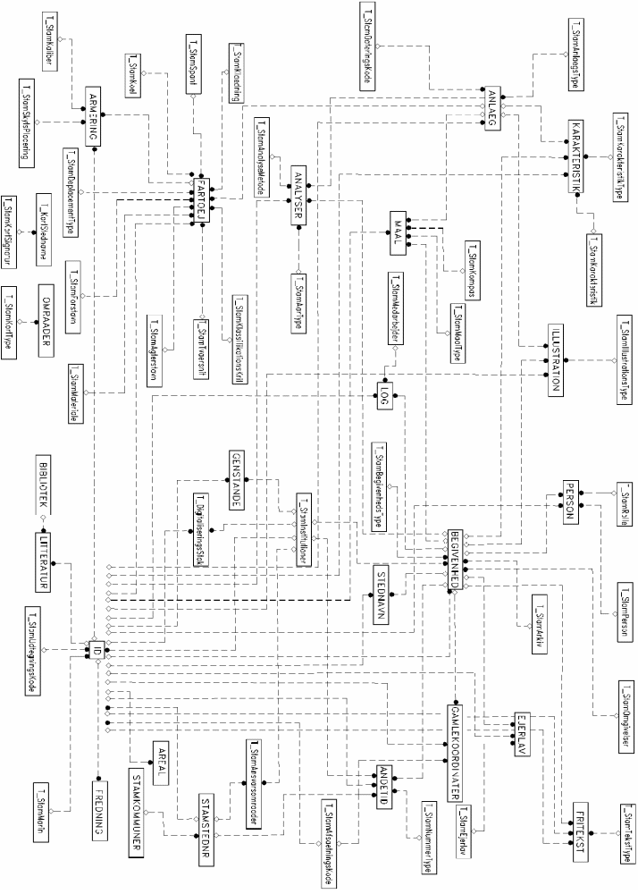
Denmark: The National Archaeological Record (Det Kulturhistoriske Centralregister - DKC)
Figure 3: DKC, Denmark, Data Model
The DKC database is designed to hold information about sites and monuments of cultural-historical interest from all historic and prehistoric periods including both land and the sea-bed sites.
The application is PC based using the Microsoft ACCESS-database management system interfacing with digital stored raster maps in 1:100.000 and 1:25.000 as well as a selection of vector maps (an in-house made application).
The main tables in the datamodel are identified by NAMES in capital letters while the many auxiliary tables are recognised by the name format: T_Name).
The primary tables in the models are: ID, ANLAEG and BEGIVENHED. The ID table includes all the basic facts about the identification and location of the site. Information concerning the actual structures (ie barrow or field-system) and their dating are stored in the ANLAEG table, while the BEGIVENHED table holds details about all the archaeological events (ie excavation or restoration) related to the site or monument.
Other important tables are FREDNING (protected status), GENSTANDE (artefacts), PERSON (person), MAAL (dimensions) and AREAL (area).
The large FARTOEJ and related tables are designed to hold data about ships and vessels. This complex of tables is not yet in regular use at the National Record.
Simplifications will be made to the model in the near future, as it still includes elements associated with the previous version of the system.

Figure 4: MONARCH, England, Data Model
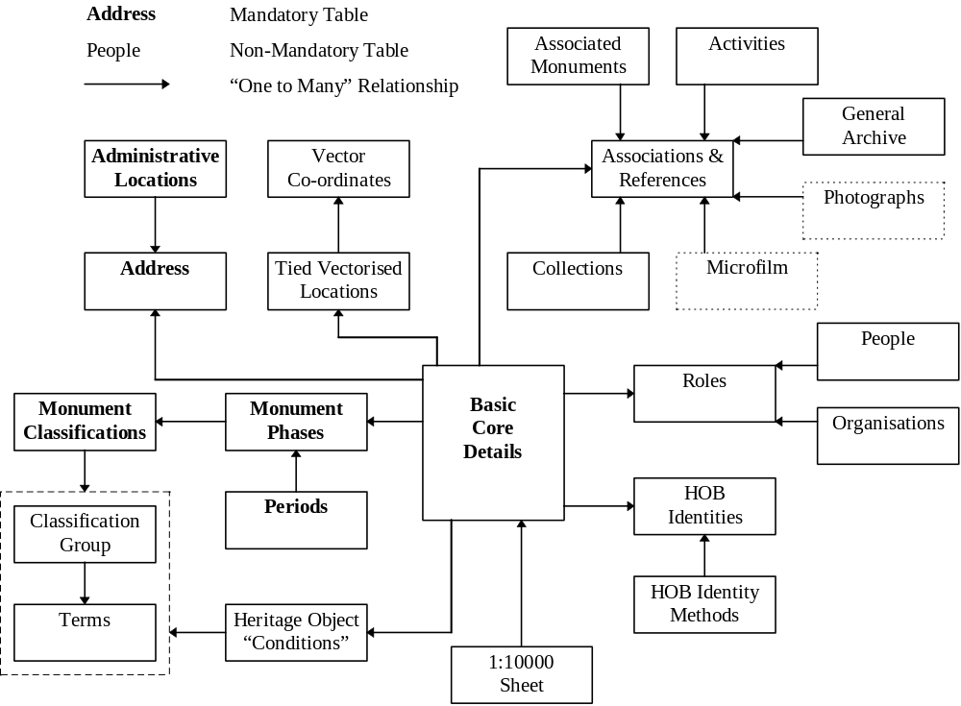
England: The MONARCH Heritage Database Management System
Royal Commission on the Historical Monuments of England
MONARCH is the RCHME’s computerised records management system, providing efficient access to the Commission’s computerised information.
This unique database management system integrates all information held in the National Monuments Record. It contains over 250,000 detailed records on archaeological sites, shipwrecks and historic buildings as well as information on 35,000 events and over 200,000 pieces of archive.
The system has been developed using the ORACLE™ relational database management system (RDBMS) and can be operated on any of the hardware platforms supported by it. The RCHME currently runs MONARCH on a UNIX-based multi-user wide area network. A stand-alone PC version running under MS-DOS has also been produced, suitable for local cultural resource management.
There are over 130 tables of information in MONARCH and the data model presented here is a simplified version. The three core entities are monuments, archives and activities. Each of these areas is regarded as being a top level data type. The system matches records of monuments and sites with associated details of activities (such as excavations and surveys) and archives (such as photographs, plans and written records).
The data model presented here is for land-based monuments. The primary table is BASIC CORE DETAILS which identifies the monument. Information concerning the type and dating of the monument can be recorded (MONUMENT CLASSIFICATIONS), the monument can be located administratively (ADDRESS) and spatially (TIED VECTORISED LOCATION) and the condition or status can be noted (HERITAGE OBJECT CONDITIONS). In addition, people and organisations can be associated with the monuments (ROLES). It is also possible to make links with any activities associated with the monument (ACTIVITIES), and the archive produced as a result of these activities can be referenced (eg COLLECTIONS, GENERAL ARCHIVE). These links, and links with other monuments, are made via an intermediary table (ASSOCIATION AND REFERENCES).
Figure 5: DRACAR, France, Data Model
France: the DRACAR System
Ministère de la Culture et de la Francophonie, Direction du Patrimoine, Sous-direction de l’archéologie
The DRACAR system has been designed to manage all known archaeological sites in France. It was developed using a UNIX-based ORACLE RDBMS. The information is stored in a central computer which is accessed by 25 regional users as well as by the central national office for archaeology (sous direction de l’Archéologie)
The information is stored in tables, with the ‘SITE’ and the ‘DEMANDE/OPERATION’ tables being the core. The ‘DEMANDE/OPERATION’ table records requests for authorisation for archaeological fieldwork as well as administrative information about the field operations. These operations may, or may not, be linked to one or more sites. In the same way, a site may, or may not, be linked to one or more field operations. The ‘DOSSIER’ table allows the management of planning documents which are required to be submitted by developers. The ‘DEPOT’ table stores information related to the location, both definitive or provisory, of archaeological objects. A number of other tables complete the model.
In the diagram, the rectangular boxes represent model items. The grey boxes contain semantic objects. The rectangular boxes between two objects indicate a relationship between them. The circles marked ‘CIF’ indicate an inclusion constraint.

Netherlands: The ARCHIS system
Figure 6: ARCHIS, Netherlands, Data Model
The Dutch archaeological information system, ARCHIS, consists of a central database, containing data about find-spots and monuments, and an integrated raster-based Geographical Information System (GIS). The textual data is stored in the INFORMIX-ONLINE relational database management system (RDBMS) and the GIS used is GRASS. The system is running under the UNIX operating system.
The observation’s data-set contains information about observed and recorded find-spots. All find-spots are stored as point locations.
The monument’s data-set concerns areas in which one or more valuable sites are located. These areas are protected by law or by means of local council zoning plans. Most monuments data are of a general and administrative character.
In the ARCHIS system observations can be linked with monuments by means of the GIS.
The data in the ARCHIS-database are highly structured and standardised. Relevant archaeological terms are standardised as mnemonic codes. These codes and their descriptions together form a complete register of archeological terms and are stored, as part of the database, in reference tables.
The data model shows the main tables concerned with observations (LOCATION, OBSERVATION, DESCRIPTION OBSERVATION, STRATIGRAPHY, ARTEFACTS, COLLECTION, DOCUMENTATION, PUBLICATION) and monuments (MONUMENT, DESCRIPTION MONUMENT, PROTECTION, LICENSE, OFFENCE). All tables concerning monuments are indicated by double boxes.

Blank Page

